Front End Engineering-II

Project Report Semester-IV (Batch-2022)

# Interactive Music Player



### Supervised By: Submitted By:

Mr. Rajender Kumar Gurinder Singh : 2210990337 Gurkirat Singh : 2210990339

Gyan Biswal : 2210990354

Group : G30

**Department of Computer Science and Engineering**

**Table of Contents**

|  |  |  |
| --- | --- | --- |
| **sr. no.** | **Section** | **Page no.** |
| **1.** | **Introduction** | **3** |
| **2.** | **Problem Definition and Requirements** | **4** |
| **3.** | **Key features** | **6** |
| **4.** | **Results** | **8** |
| **5.** | **References** | **11** |

# Introduction

In the digital age, music has become an integral part of daily life, with countless platforms and applications

providing users access to their favorite tracks. This project report details the development of a music player

application created using React.js, a powerful JavaScript library for building user interfaces. The goal of this

project was to design and implement a modern, user-friendly music player that allows users to play, pause, skip,

and manage their music playlists efficiently.

React.js was chosen for its component-based architecture, which facilitates the creation of reusable UI components,

and its virtual DOM, which enhances performance by updating only the necessary parts of the user interface. This

approach not only streamlines the development process but also ensures a responsive and interactive user

experience.

The music player project encompasses several core features, including an intuitive user interface, playlist

management, audio controls, and responsive design to ensure compatibility across various devices. By leveraging

React.js, this project aims to demonstrate how contemporary web technologies can be utilized to build dynamic

and efficient web applications.

This report will cover the project's objectives, the technologies and tools used, the implementation process, and the

challenges encountered along the way. Through this detailed examination, the report aims to provide insights into

the practical application of React.js in developing a functional and aesthetically pleasing music player.

**Why React.js?**

React.js was selected for this project due to its component-based architecture, which allows for the creation of reusable and

modular UI components. This approach significantly simplifies the development and maintenance of complex user interfaces.

Additionally, React's virtual DOM mechanism ensures high performance by minimizing direct manipulation of the actual

DOM, leading to faster and more efficient updates.

**Background and Motivation**

In today's digital landscape, the consumption of music has significantly evolved from physical media to streaming

services and digital downloads. With the growing demand for personalized and accessible music experiences, there

is a continuous need for innovative music player applications that cater to diverse user preferences. This project

aims to contribute to this evolution by developing a music player using React.js, focusing on providing a seamless

and enjoyable user experience.

**Project Overview**

This project report details the development of a music player application created using React.js, a popular

JavaScript library known for building dynamic and responsive user interfaces. The primary objective of this project

was to design a music player that offers essential functionalities such as play, pause, skip, and playlist

management, wrapped in a sleek and intuitive user interface.

# Problem Definition and Requirements

## Problem Definition

With the proliferation of digital music, users seek efficient and customizable ways to manage and play their

favorite tracks. Existing music player applications often fall short in areas such as user interface design,

performance, and functionality. Many users desire a music player that is not only visually appealing and easy

to use but also robust in handling playlists and providing smooth playback without lag or interruptions.

## 2.1 Key Issues

## User Interface Complexity: Many music players have cluttered interfaces, making them difficult to navigate

## and use efficiently.

## Performance Limitations: High resource consumption and lag during playback or while managing large

## playlists can significantly degrade the user experience.

## Limited Customizability: Users often lack the ability to customize their music experience according to their

## preferences.

## Inconsistent User Experience: Lack of responsive design can lead to poor user experiences across different

## devices and screen sizes.

## State Management Challenges: Efficiently managing the state of audio playback and playlist data is crucial

## for a seamless experience.

## 2.2 Objectives

## The primary objective of this project is to develop a music player application that addresses these issues by:

## Offering a clean and intuitive user interface.

## Ensuring high performance and responsiveness.

## Providing robust playlist management features.

## Delivering a consistent experience across various devices.

## Efficiently managing state and handling user interactions seamlessly.

## Requirements

## 

## Functional Requirements

## User Interface

## The application should have a modern, user-friendly interface.

## It should display track information, including title, artist, and album art.

## Provide audio controls such as play, pause, next, previous, and volume control.

## Playlist Management

## Users should be able to create, edit, and delete playlists.

## Users should be able to add or remove tracks from playlists.

## The application should support importing and exporting playlists.

## 

## Playback Features

## Smooth playback of audio files with minimal latency.

## Support for various audio formats (e.g., MP3, AAC).

## Ability to shuffle and repeat tracks.

## Responsive Design

The application should be fully responsive and function seamlessly on desktops, tablets, and mobile devices.

Ensure consistent user experience across different screen sizes.

**State Management**

Efficiently manage the state of playback controls and playlist data.

Persist user data (e.g., playlists, playback position) across sessions.

**Non-Functional Requirements**

**Performance**

The application should load quickly and handle large playlists without significant performance degradation.

Optimize resource usage to ensure smooth playback and UI interactions.

**Usability**

The interface should be intuitive and require minimal learning curve for new users.

Provide clear feedback for user actions (e.g., visual cues for play/pause).

**Scalability**

Design the application to handle an increasing number of tracks and playlists efficiently.

Ensure the architecture can support future feature expansions.

**Security**

Securely manage user data and preferences.

Implement proper error handling and validation for user inputs.

**Maintainability**

Use a modular code structure to facilitate maintenance and updates.

Ensure the code is well-documented and follows best practices.

1. **Key Features**

**Intuitive User Interface**

**Modern Design:**

The application features a sleek and contemporary design, ensuring that users find it visually appealing and easy to navigate.

**Track Information Display:**

Detailed information about the currently playing track, including the title, artist, and album art, is prominently displayed.

**User Feedback:**

Clear visual cues and animations provide immediate feedback for user actions, enhancing the overall user experience.

**Comprehensive Audio Controls**

**Play/Pause Functionality:**

Users can easily play or pause their music with a single click.

**Next/Previous Track:**

Users can skip to the next track or go back to the previous one with dedicated buttons.

**Volume Control:**

An intuitive volume slider allows users to adjust the audio level to their preference.

**Playback Progress:**

A progress bar displays the current position of the track and allows users to seek to different parts of the track.

**Robust Playlist Management**

**Create and Edit Playlists:**

Users can create new playlists, add or remove tracks, and edit the playlist name.

**Delete Playlists:**

Unwanted playlists can be easily deleted with a simple action.

**Import/Export Playlists:**

Support for importing and exporting playlists to and from external sources, providing flexibility in managing music collections.

**Advanced Playback Features**

**Shuffle and Repeat:**

Users can enable shuffle mode to play tracks in random order and repeat mode to loop the current track or playlist.

**Support for Various Audio Formats:**

The player supports multiple audio formats, ensuring compatibility with a wide range of music files.

**High-Quality Audio Playback:**

The application ensures smooth and high-quality audio playback with minimal latency.

**Responsive Design**

**Cross-Device Compatibility:**

The application is fully responsive and provides a consistent user experience across desktops, tablets, and mobile devices.

**Adaptive Layouts:**

The user interface adapts to different screen sizes and orientations, ensuring optimal usability on all devices.

Efficient State Management

**Persistent State:**

The application remembers user settings and preferences, such as the last played track and volume level, across sessions.

**Real-Time Updates:**

Changes in playback controls and playlist management are reflected in real-time, providing a seamless user experience.

**Performance Optimization**

**Fast Loading Times:**

The application is optimized to load quickly, even with large music libraries.

**Efficient Resource Usage:**

The application minimizes resource consumption to ensure smooth performance, even on lower-end devices.

**Security and Privacy**

**Data Security:**

User data, including playlists and preferences, is securely managed to protect privacy.

**Error Handling:**

Robust error handling mechanisms ensure that the application gracefully handles any issues that arise during usage.

**Extensibility**

**Modular Architecture:**

The codebase is structured in a modular fashion, allowing for easy addition of new features and enhancements.

**API Integration:**

The application is designed to integrate with third-party APIs for fetching music metadata, album art, and other relevant information.

1. **Results**

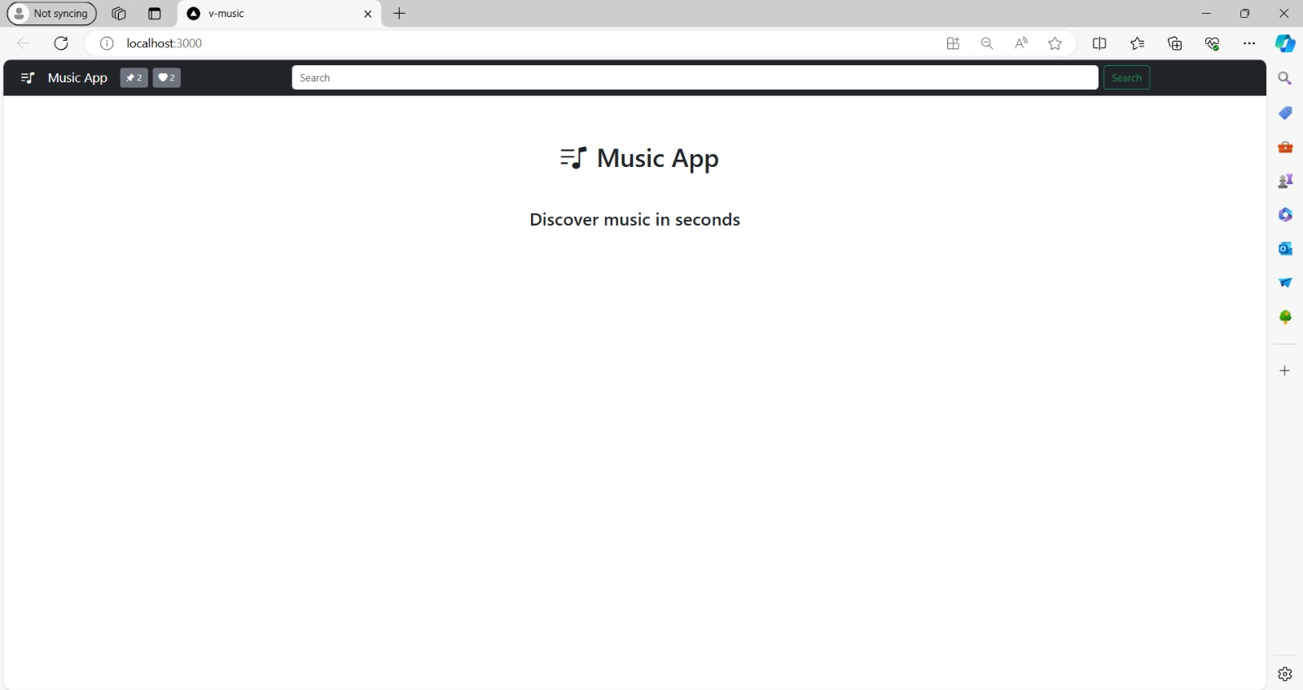

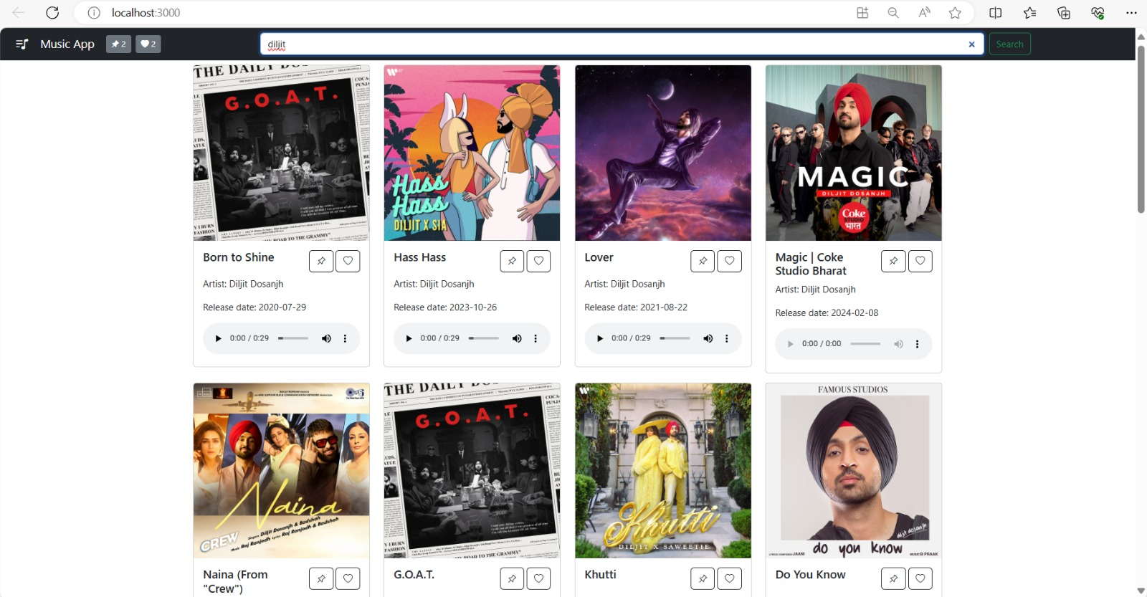

**Search Bar**

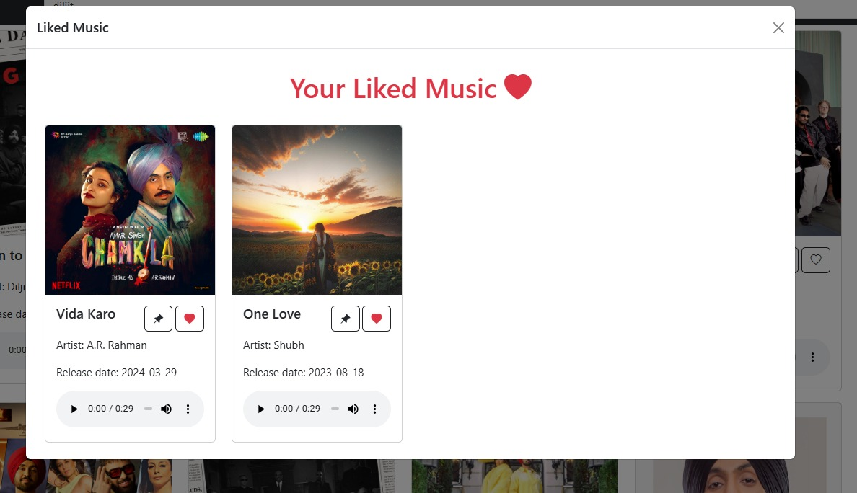

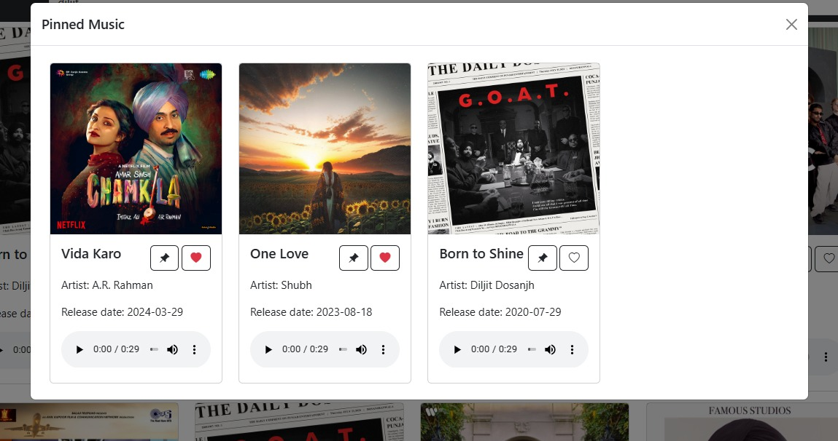

1. **References**

**React Documentation**

Official React.js Documentation. Available at: https://reactjs.org/docs/getting-started.html

**Redux Documentation**

Official Redux Documentation. Available at: https://redux.js.org/

**React Router Documentation**

Official React Router Documentation. Available at: https://reactrouter.com/

**Web Audio API Documentation**

Web Audio API Documentation by MDN Web Docs. Available at: <https://developer.mozilla.org/en-> US/docs/Web/API/Web_Audio_API

**Axios Documentation**

Official Axios Documentation. Available at: https://axios-http.com/docs/intro

**HTML5 and CSS3 Resources**

HTML5 and CSS3 Documentation by MDN Web Docs. Available at: <https://developer.mozilla.org/en-> US/docs/Web/Guide/HTML/HTML5

https://developer.mozilla.org/en-US/docs/Web/CSS

**React Tutorials**

"React for Beginners" by Wes Bos. Available at: https://reactforbeginners.com/

"Learn React" by Codecademy. Available at: https://www.codecademy.com/learn/react-101

**Styled-Components Documentation**

Official Styled-Components Documentation. Available at: https://styled-components.com/docs

**General JavaScript Resources**

"JavaScript: The Good Parts" by Douglas Crockford. O'Reilly Media, 2008.

MDN Web Docs JavaScript Guide. Available at: https://developer.mozilla.org/en-US/docs/Web/JavaScript/Guide

**Git and Version Control**

Pro Git by Scott Chacon and Ben Straub. Apress, 2014. Available at: https://git-scm.com/book/en/v2

**Other Online Resources**

Stack Overflow. Various questions and answers on React.js and related technologies. Available at: https://stackoverflow.com/

YouTube tutorials on React.js and music player development.

**APIs for Music Data**

Spotify Web API Documentation. Available at: https://developer.spotify.com/documentation/web-api/

Last.fm API Documentation. Available at: https://www.last.fm/api